The above quote best defines the behaviour of a human on how a person sees a product and consumes it. Have you ever wondered how some of the OTT platforms you use like Netflix recommends movies and shows exactly to your likings or how YouTube recommends videos that matched your interests or how Amazon keeps giving you recommendations and your one product purchase turns into an entire cart of 10 or how Spotify curates you a new playlist every day.

It’s simple they use recommendation systems. These are systems designed to recommend things to the user based on many different factors.

This article helps you understand how they are able to do it.

**Table of contents**

1)What is a recommendation system?

2) why do we need recommendation systems?

3)Types of recommendation system

4)Implementation of a movie recommendation system

**1)What is a recommendation system?**

Recommendation system is an information filtering technique that aims to predict users interests and recommend product items that quite likely are interesting for them.  They are among the most powerful machine learning systems that online retailers implement in order to drive sales.

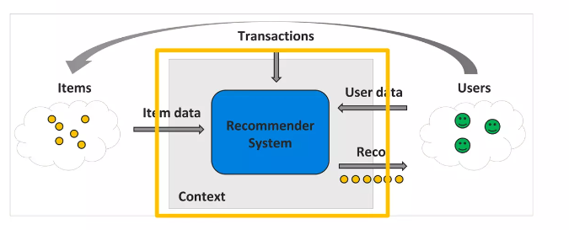

**2) why do we need recommendation systems?**

* **Improved user experience:** Recommendation systems help users discover new products or content that they might be interested in, based on their previous preferences. This can make the user experience more personalized and enjoyable.
* **Increased sales and engagement:** By showing users relevant recommendations, a recommendation system can help drive more traffic to a website or an app, and can encourage users to engage with the content or products being recommended. This can lead to increased sales and revenue for the business.
* **Enhanced customer loyalty:** By providing personalized recommendations, businesses can show customers that they understand their interests and preferences. This helps build customer loyalty and encourage customers to return to the site or app in the future.
* **Better targeting of marketing campaigns:** Recommendation systems can help businesses gather data on customer preferences and interests, which can be used to target marketing campaigns more effectively. This can help businesses reach the right customers with the right messages, which can lead to improved marketing ROI.
* **Improved efficiency and cost savings:** By automating the process of generating recommendations, businesses can save time and resources that would otherwise be spent on manual curation of content or products. This can lead to improved efficiency and cost savings.

**3)Types of recommendation system**

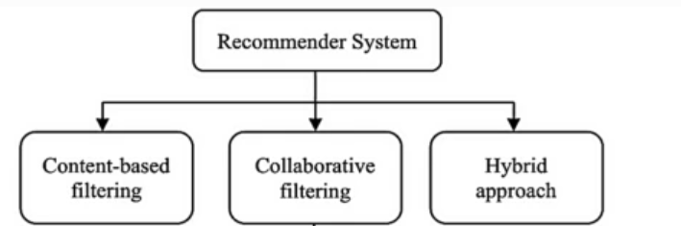

1. **Content-based recommender system**

Content based recommendation system is based on the similarity between the content that is being consumed. It means, suppose if two contents are similar in nature and if the user likes one of the contents, then the user is assumed to like the other also

Best examples of a content-based recommendation system are a movie recommendation system. Suppose you like a movies of a certain genre then further movies are recommended to you in that genre

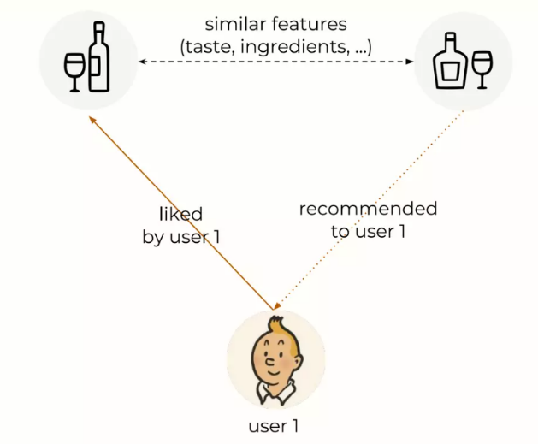

1. **Collaborative filtering**

Collaborative filtering approach makes use of the measure of similarity between users. This technique starts with finding a group or collection of user X whose preferences, likes, and dislikes are similar to that of user A. X is called the neighbourhood of A. The new items which are liked by most of the users in X are then recommended to user A.

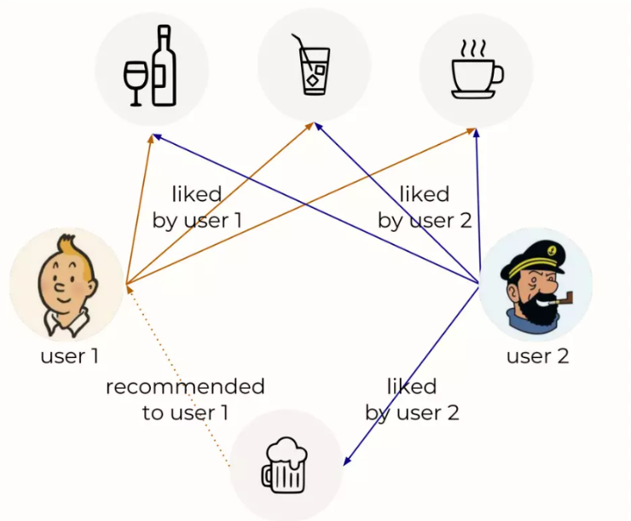

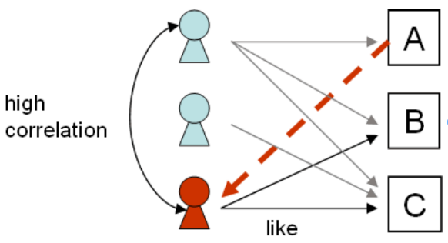There are two main approaches in this method:

1. **User-based collaborative filtering**

* Use user-item rating matrix
* Make user-to-user corelations
* Find highly corelated users
* Recommend items preferred by those users

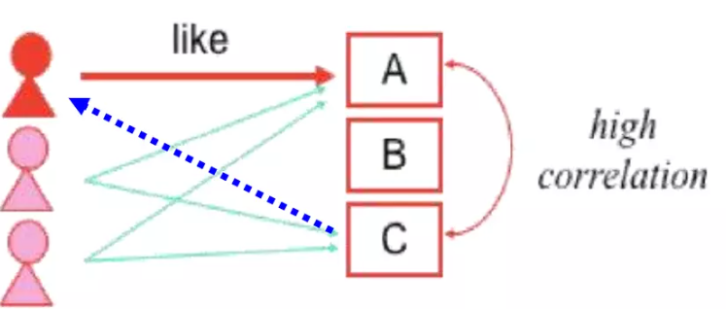

1. **Item-based collaborative filtering**

* Use user-item rating matrix
* Make item-to-item corelations
* Find items that are highly corelated
* Recommend items with highest corelation

*#Hybrid approach is the mixed approach of both the methods*

**4)Implementation of a movie recommendation system**

Now let’s build a Movie recommendation system!!!

To build a movie recommendation system we have used we have used tmbd 5000 movie dataset

*##code*

Importing libraries

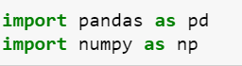

Importing the dataset

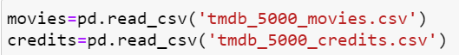

The data consists of two files.one consists of movies details and other consists details of movie credits

First, we merge the two data frames because both the datasets speak about the same things. We can merge both the datasets based on either id or title. Here I am merging them based on the title



Now the dataset contains 23 columns. I only need those that can give me enough information about the movies to recommend



*#Preprocessing*

Checking for null values





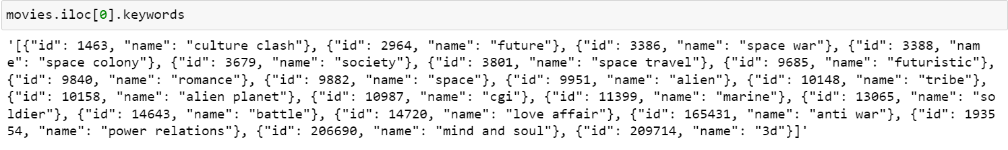

As we can see the genres and keywords column is in the form of dictionary and I only require main keywords from them. For example, in the first row I only need words ['Action','Adventure','Fantasy','Science Fiction']

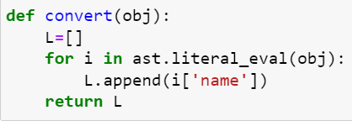





From cast column I only need names of top 3 cast in each movie

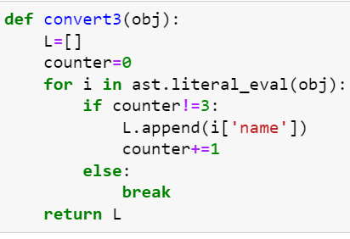



From crew column I only need the name of the director

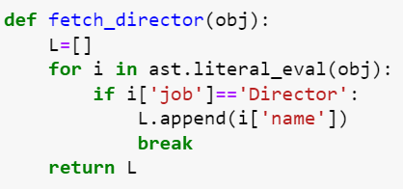



Column overview is in string format. I need to convert it into list so that I can concatenate it with other columns in future



now there is a problem with spaces. when there is space between two words representing same person but the system considers it as two different words. so, to avoid this problem we will remove spaces between words



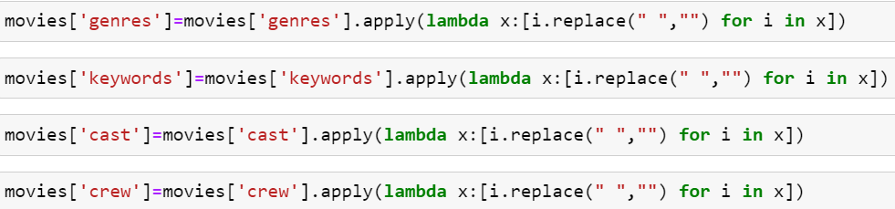

concating columns 'overview','genres','keywords','cast','crew' into single new column 'tags'. we will use this column to make recommendation



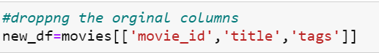

Converting the tags column to string



converting all the letters into lower case(recommended)



converting text to vectors. To do this we call upon countvectorizer. this method uses the concept of bag of words (BOG)

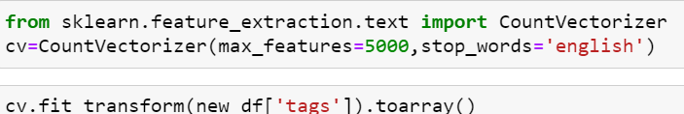





This function gives the feature names

Now since multiple different words mean the same thing, to eliminate this problem we perform stemming

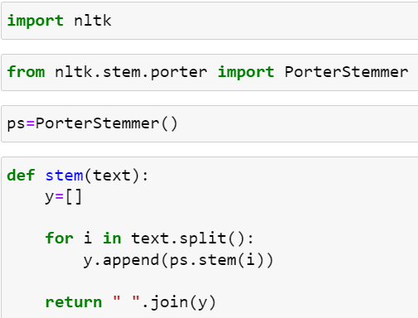



Now we again convert the words into vectors

we have to find distances between the vectors. we cannot use Euclidian distances because Euclidian distance fails at higher dimension. we use cosine similarity





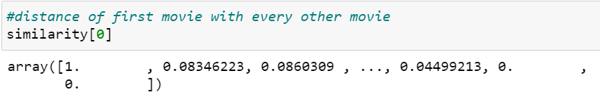

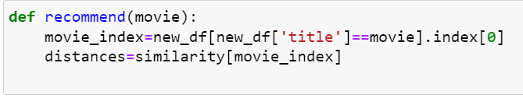

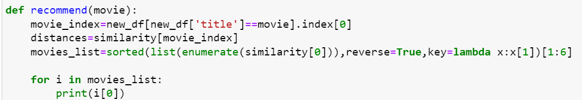

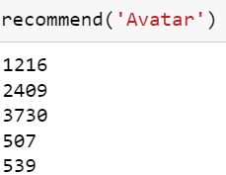

We have got the recommended movies but we have got the indexes of the movie not the names of the movies

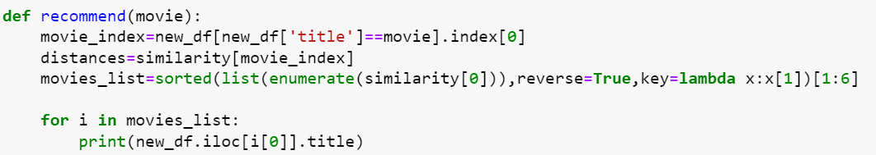

**OUTPUT**

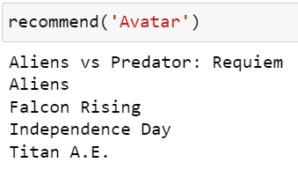

**References**

1. <https://en.wikipedia.org/wiki/Recommender_system>
2. <https://ieeexplore.ieee.org/document/9257290>
3. <https://link.springer.com/article/10.1007/s00799-022-00339-w>
4. <https://www.educative.io/courses/grokking-ai-for-engineering-product-managers/m2XRAyXO0qr#what-are-recommendations>
5. <https://towardsdatascience.com/recommendation-systems-explained-a42fc60591ed>
6. <https://medium.com/pathtoai/recommendation-systems-fb437f89d4ea>
7. <https://dida.do/blog/recommendation-systems-an-overview>